The efficacy of Siddha medicine Brami Nei with varma therapy in Mantha Sanni (Autism spectrum disorder) in children – A case report
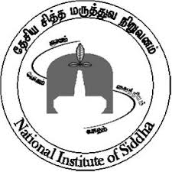
*Dharshini Priya G, ²Arul Mozhi.P, ³Meenakshi Sundaram.M, ⁴Banumathi.V
*III Year PG Scholar, Lecturer², Head of the Department³ Department of Kuzhandai Maruthuvam,
Director⁴ National institute Of Siddha
(Paediatric)

Abstract:
Mantha Sanni (Autism) is a mukkuttra disease that is imbalance of all the three main fundamental principles of Vatham, Pitham and Kabam. Mantha Sanni is a neuro developmental disorder typically appearing in the first one and half years of life and characterised by impaired social and communication skills. . In the all over the world, the surveillance study identified 1 in 68 children suffering with ASD. In India, the prevalence ratio is 1:46. It is about 4.5 times more common among boys (1:48) than among girls (1:189).The higher prevalence rate was observed in the rural area. Socioeconomic status may be one of the fundamental indicators for ASD in India. In that way Autism spectrum disorder is the world most common disorder in Children. For children identified with Mantha Sanni (ASD), Siddha has a range of internal medicine Brami nei and external therapy (Varma) that are done for an average of 90 days and repeated periodically.

Introduction :
Mantha sanni (Autism) is a mukkuttra disease that is imbalance of all the three main fundamental principles of Vatham, Pitham, and Kabam. Historically, autistic spectrum disorders (ASDs) have been described, defined, and differentiated from other neurological conditions primarily on the basis of case studies. Special-needs children is a wall to wall term those who have both physical and mental disabilities caused by neuronal damage. The percentage of disabled children in developing countries is generally higher than in developed countries, it is estimated that 6 to 10% of children in India are born disabled. With one in 68 children being diagnosed with Autistic Spectrum Disorder (ASD) in India. At least 70 million individuals worldwide have Autism, 10 million in India" India itself. In the all over the world, the surveillance study identified 1 in 68 children suffering with ASD. In India, the prevalence ratio is 1:46. It is about 4.5 times more common among boys (1:48) than among girls (1:189). The higher prevalence rate was observed in the rural area. Socioeconomic status may be one of the fundamental indicators for ASD in India.
Mantha Sanni is a Neuro developmental disorder typically appearing in the first one and half years of life and characterized by impaired social and communication skills. Parents want to cure their children with the easily available of conventional therapies. At this juncture Siddha gives relief to parents and their children in economical way. We receiving a case of approximately more than 80 ASD children reported in our Kuzhandai Maruthuvam OPD past one year.
We had a separate therapeutic for this type of disorder for more than 2000 years ago. In our Siddha paediatric text the symptoms of ASD are about resembled with Mantha Sanni. Many siddha literatures like Agasthiya Mannidakirukunool are available for this disorder. Although there are many existing therapies in modern world till now there is no complete cure for ASD in children. For children identified with Mantha Sanni (ASD), Siddha has a range of internal medicine Brami nei and external therapy (Varma) that are done for an average of 90 days and repeated periodically.
In this study, I have to present 3 case reports of ASD children based on the assessment scale. The main course of treatment are Brami Nei as internal and Varmam as External therapy in the recommended dose as per Siddha pharmacopeia for 3 months. After 3 months, ASD children improve the cognitive skills and eye to eye contact Hyperactivity reduced well. Most of the formulation acting on psyche is ghee based. It is well established that the drugs to have its action on brain should have the capacity to cross the blood brain barrier and for the purpose ghee based Brahmi Nei is recommended for ASD in children. Brahmi Nei is to rejuvenate the mind, enhance memory and concentration and to directly influence the quality of consciousness. Manipulative therapy like varma is to enhance the mind calming activity with sound sleep, good eye to eye contact and to reduce anxiety, hyperactivity. All the ingredients in both Internal medicines are herbal. So my attorney has to conclude the Siddha management therapy might be good and safest. It will be definitely efficacy in treating ASD children. Hence, Brami Nei as internal Varmam as External therapy may have a role to curing the ASD children.
Aim:
To evaluate the efficacy of Siddha medicine Brami Nei as Internal medicine and Varmam as External therapy in the management of Mantha Sanni (Autism spectrum Disorder) in Children.
Objective:
To observe the efficacy of Siddha medicine Brami Nei as Internal medicine and Varmam as External therapy in the management of Mantha Sanni (Autism spectrum Disorder) in Children. To explore a new pathway for Autism children using siddha therapeutic management.

Materials and Methods :
Method of Study type
Study and Practical Place : OPD & IPD
Kuzhanthai Maruthuvam : NIS
Study period : 3 Months (90 Days continuously)
Sample size : 5 ASD patients
Dose : 3-6 years (2.5ml), 6-12 years (5ml) twice a day with food
Children were assessed for improvement on 0th, 30th, 60th, 90th day of treatment and the results were filled in the assessment forms. The results were analysed by computing the scores of assessment form of Autism Clinical Assessment Parameters
Experimental Formulation & Procedures
Internal Medicine: Brami Nei
External therapy: Varmam
Autism clinical assessment parameters:
- Social relationship and reciprocity
- Emotional responsiveness Behavioural patterns
- Sensory aspects
- Verbal knowledge
- Nonverbal knowledge
Results and Observation:
Case Study 1-Mast J.A.Haribalan – OP No – H66746
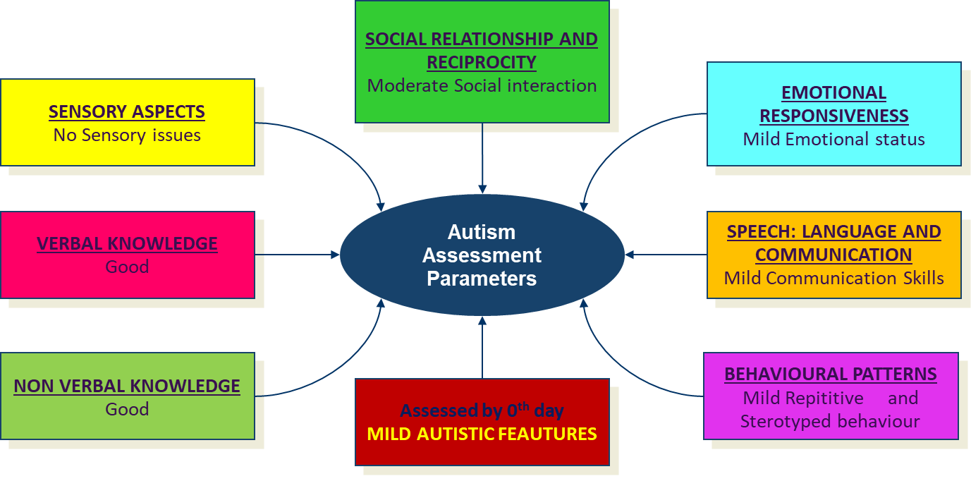
Haribalan is an 11 years old male Child was born by LSCS, Birth weight 3.4 kg, Child had cried immediately after birth. There was no history of Seizure. Global developmental Milestones are normal. At the age of 2 years parents noticed he had difficulty to challenged day to day life activities
Summary of Haribalan activities from 0th to 90th days

Case Study - 2- Baby Rithumitha– OP No – J30514
Rithumitha is a 4 years old Female Child was born by LSCS, Birth weight 2.65 kg, Child had cried immediately after birth. There was no history of Seizure. Global developmental Milestones are normal. At the age of 1 1/2 years parents noticed she had difficulty to challenged day to day life activities.
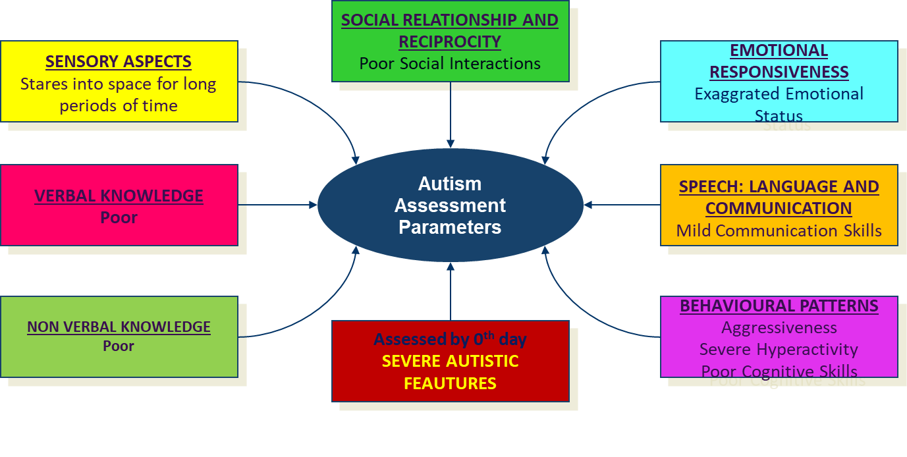
Summary of Rithumitha activities from 0th to 90th days

Case Study –3- Mast Rithish– OP No – I 72534
Rithish is a 7 years old Male Child was born by LSCS, Birth weight 3 kg, Child had cried immediately after birth. There was a history of Seizure at the age of 1 year. Global developmental Milestones are normal. At the age of 1 1/2years parents noticed he had difficulty to challenged day to day life activities.

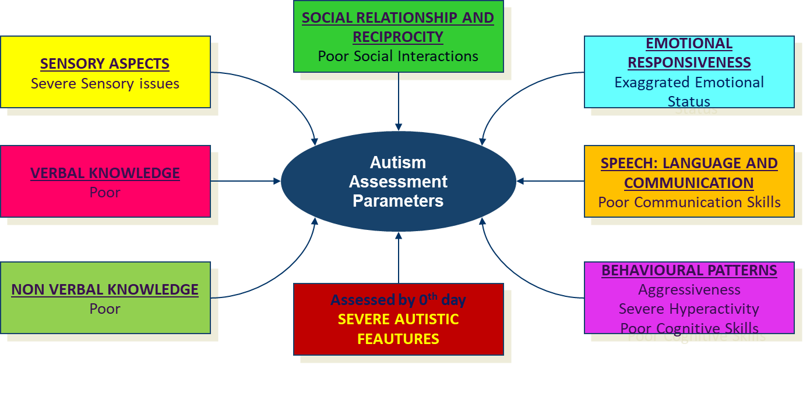
Summary of Indumathi Activities from 0th to 90th day

Summary Of Case Study :
After the treatment period of 3 months, the results were shown in all the 3 ASD children are
- Improvement in cognitive skills,
- Improvement in eye to eye contact
- Reduction in hyperactivity behaviour.
- Improved in sitting tolerance.
- Enhancing the mind calming activity.
- Able to try to speak the verbal with limited language skills.
- Able to mingle the other children
- Giving a good sound sleep
- Able to understand the situations
- Able to sit calm in outdoors
- Able to try to reading, writing, drawing and sketching in school.
- Also reduced the parents stress
So the Siddha internal and external therapies are enhancing the ‘quality of life’ of ASD children

Note:
Severe | 175-349
severe to Moderate | 350-524
Moderate to Mild | 525-699
Mild | 700-824
Mild to Normal | 825 & Above

Discussion :
Most of the formulation acting on psychic disorder is ghee based. Brahmi Nei is well established siddha medicine as brain tonic and should have the capacity to cross the blood brain barrier, for that purpose ghee based Brahmi Nei is recommended for ASD in children. Brahmi Nei is to rejuvenate the mind, enhance memory and concentration and to directly influence the quality of consciousness. Brahmi Nei also reduced the oxidative stress, activate the serotogenesis and cholinergic system, enhancement of synaptic plasticity, increase the metabolism of neurotransmitters and also enhances the nerve impulse transmission. Varmam therapy may simultaneously calming, stimulating, improving day time alertness and focus while reducing stress and improving the quality of sleep.

Conclusion :
Our perception of autism has evolved over time. Sixty years ago autism was nothing more than an unrecognized developmental delay generally lumped in with mental retardation. Today it is recognized as an independent neurologically based disorder of significance, a major public health problem, and a topic of much research. We will overcome this disease by regular practice of Siddha treatment and also with help of Role of Families, Educational services, Effective Interventions, Public Policies, Personal preparation. This subject need more research to be done for the cause of Autism.

Reference :
- Aathma ratchamirthammenum vaithya sarasangiragam- Kandha saami mudhaliyaar Pg.no: 265
- Kuzhanthai Maruthuvam (Bala vaagadam) k.s.Murugesha Muthaliyaar, Maru . Pon. Guru.sironmani P.no: 168
- Indian assessment of Autism scale - NIMHANS

