Figure-1
Pearl oyster shell | Adathoda vasica | Vitex negundo | Curculigo orchoides
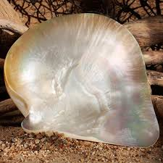 | 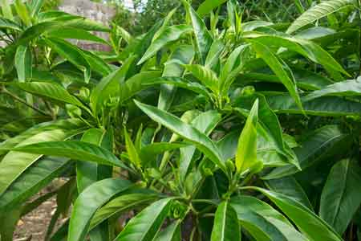 | 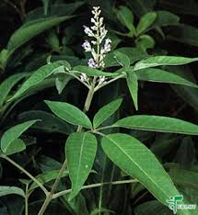 | 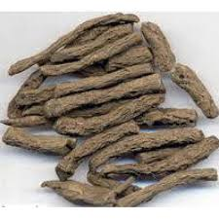
Ingredients of Muthuchippi parpam

