“A STUDY TO EVALUATE THE EFFECTIVENESS OF KSHARSUTRA LIGATION FOLLOWED BY FISTULECTOMY IN THE MANAGEMENT OF BHAGANDARA (FISTULA IN ANO)”

Dr. Raut Subhash¹, Dr. Kedar Nita², Dr. Akulwar Akanksha³
^{*1}(Professor & H.O.D, Department Of Shalyatantra, Govt. Ayurved College & Hosp., Nagpur, Maharashtra, India, drsyraut.@yahoo.co.in. Mob.9422108928)
^{*2}(Professor, Department Of Shalyatantra, Govt.Ayurved College & Hosp., Nagpur, Maharashtra, India, drnita6@gmail.com. Mob.9960640613)
^{*3}(PG. Scholar, Department Of Shalyatantra, Govt. Ayurved College & Hosp., Nagpur, Maharashtra, India, akankshaakulwar09@gmail.com, Mob.9579208086)

Corresponding Author*
Dr. Akanksha S. Akulwar,
Post Graduate Scholar,
Department of Shalyatantra,
Govt. Ayurved College and Hospital,
Nagpur-440024, Maharashtra, India
Email: akankshaakulwar09@gmail.com
Mob. 09579208086

ABSTRACT:
‘Bhagandara’ (Fistula in ano) described by Aacharya Sushruta can be categorised under ‘Dushta Vrana’ i.e noncollapsable, unhealthy infected tunnelling wound with persistant drainage of pus. According to Sushruta treatment given for Bhagandara is ‘Chedana Karma’ (excision of tract i.e Fistulectomy) along with Ksharsutra Chikitsa. But as the surgical techniques are opted in infected stage of wound it may lead to complications like recurrence, infection and incontinence. Ksharsutra (medicated seton) is a device to deliver medicine to the non-approchable wound surface causes ‘Shodhana’ (Purification) and ‘Ropana’ (Healing) of fistulous tract simultaneously. But, time duration required for this treatment is slightly longer as compared to Fistulectomy.
Methodology: The study was an open clinical trial done on five patients, clinically diagnosed as a case of low anal fistula. The aim was to minimise the duration of treatment and to evaluate the pattern and duration of healing of post fistulectomy surgical wound if it performed after achieving Shuddhavastha by Ksharsutra. Study group were treated with Ksharsutra ligation under local anaesthesia and as Shuddhavastha was achieved Fistulectomy was done under spinal anaesthesia.
Result: After Ksharsutra ligation Shuddha Vrana lakshana was achieved on third or fourth sitting, whereas the Unit Healing Rate observed after fistulectomy was 0.15 sq.cm/day. No recurrence was noted in any of the 5 patients.
Conclusion: Combine therapy of Ksharsutra ligation followed by Fistulectomy curtail the prolong duration of treatment which is quite longer in Ksharsutra therapy. It also shows significant results in recurrence as surgical procedure is opted in Shuddhavastha of Vrana.
KEY WORDS: Bhagandara, Fistula in Ano, Fistulectomy, Ksharasutra.

INTRODUCTION:
The art and science of surgery since days back to prehistoric era revolves around the ‘Vrana’ (wound). It denotes the discontinuity of tissue. Sushruta had emphasized the concept of Vrana^{[1]}, its aetiopathogenisis, various types and management. He described healthy and nonhealing chronic wound as ‘Shuddha Vrana’^{[2]} and ‘Dushta Vrana’^{[3]} respectively. He had also described the concept of “Nadivrana”^{[4]} (Sinus) which can be categorized under Dushta Vrana that is infected non-healing ulcer which is noncollapsable and nonapprochable.
In Su.Chi 8/4 treatment given for Bhagandara^{[5]} (Fistula in Ano) is “Saashayet Uddharet Shastren”^{[6]} i.e. Radicle excision of the cavity. In modern science also the treatment given for fistula is to laid open the track i.e Fistulotomy or excision of track i.e Fistulectomy^{[7,8]}. But the main complication after surgical treatment of anal fistulae is recurrence, infection and incontinence.^{[9]} Leaving of the main canal, failure to find internal opening or failure to excise all ramifications are the basic errors in surgical techniques for Fistula in Ano. The observational error seen in this is the surgical techniques are opted in Dushtavastha of Vrana i.e. in infected stage of wound which may leads to recurrence of Fistula.
Ksharsutra^{[10,11]} (Ayurvedic medicated seton) application as a treatment of Nadivrana, cause of a non-approchable tunnelling wound, was given by Sushruta. It is a type of Pratisarniya Kshara^{[12]}. It is a device to deliver the medicine i.e Kshara (Caustic) to the non-approachable wound surface. The Kshara delivered to the noncollapsable surface of granulation tissue has the action of debridement. It further increases the exudates by increase osmosis and flushes out the infecting organism from patent external opening. This ultimately facilitates the cavity to collapse and heal. By using this “Shodhana” (purification) property of Ksharsutra, the Vrana is transformed into Suddhavasta; it ultimately leads to Vrana “Ropana” (healing). But the standard alone Ksharsutra treatment is more time consuming as compared to fistulectomy.
Hence, with objective to curtail the prolong duration of treatment by Ksharsutra therapy and to overcome the recurrence after operative procedures, a combine therapy of Fistulectomy followed by the achievement of Shuddhavasta by Ksharsutra insertion will be performed in present study. This is undertaken with the principle that surgically created noncontagious wound promotes faster healing and minimize the duration of therapy and post Fistulectomy complications.

MATERIAL AND METHODS:
The main aim of the study was to evaluate the reduction in duration of post Fistulectomy healing of wound when performed in Shuddhavastha after Ksharsutra ligation and to minimise the duration of treatment.
Study Design: Open Clinical Trail
Place of Study: Government Ayurved College and Hospital, Nagpur

Inclusion Criteria:
- Selection of patient was done irrespective of age, sex, religion, occupation, economic status and education status.
- The patients who were diagnosed as Bhagandara (Fistula in Ano)
- Single track fistula.
- Low anal fistula.
- Track length upto 5cm.
Exclusion Criteria:
- Patient suffering from systemic diseases like TB, uncontrolled DM, Ca, Immunocompromised patients.
- Patient with high anal fistula and more than 5 cm track length.
- Patient suffering from Ca. of rectum, HBsAg and HIV.
- Patient suffering from Ulcerative colitis, Crohn’s disease and multiple fistulae will be excluded from the study.
Plan of Work:
- Five patients fulfilling inclusion and exclusion criteria were selected.
- After examining the patient by per rectal digital examination, proctoscopy and probing diagnosis was confirmed.
- Patients were initially treated with Ksharasutra ligation after every five days interval until the Shuddha Vrana Lakshana (signs) was observed.
- After achieving Shuddha Vrana Lakshana complete Fistulectomy was done under spinal anaesthesia.
- Postoperatively wound care and pain management was done and follow up of patient was done upto 6 weeks.

Preparation of Ksharasutra:
Surgical linen Barber thread gauge number 20 was manually coated eleven times with the latex of Snuhi (Euphorbia neriifolia), followed by seven coatings of latex and alkaline powder ashes of Apamarga (Achyranthes aspera) Kshara alternatively, and dried. Thereafter three coatings of latex and powder of Haridra (Curcuma longa) were given alternatively. The thread hangers are placed inside the Ksharsutra cabinet and get dried by hot air blow followed by ultraviolet radiations to make it sterile. In these way 21 coatings over the thread was completed.

Method of Ksharasutra Application:
- Patient subjected for suitable anesthesia.
- Lithotomy position was given to patient.
- For lubrication and local anaesthesia 2% xylocaine jelly was applied and probing was done for identification of fistulous track.
- Ksharsutra was tied to one end of probe and probe was removed from internal opening so that by railroad technique the Ksharsutra was placed in the fistula track, whose two ends were then tied together.
- Concomitant medication was given for pain management.
- After every 5 days interval Ksharsutra insertion was done.

Fistulectomy:
After achieving Shuddhavastha under spinal anaesthesia complete fistulectomy was done. After confirmation of the tract by injecting Methylene blue dye in the external opening, Probing will be done followed by division of the overlying tissue. Base of the wound will be curetted and left open to heal by secondary intention. Post-operatively appropriate wound care was taken.

Criteria To Assess Shuddhavasta Of Vrana
Shuddha Vrana Lakshna given by Acharya Sushruta in Su.Chi.1/7 and Su.Sutra.24/18 are
- Jivhatlaabho Mrudu Snidgdha Shlakshno Vigatvedanaha |
Suvyavasthito Nirastravcheti Shuddha Vrana iti || ^{[13]}

- Tribhirdoshaihi -anakranta Shyavoushtha Pidikisamaha |
Avedano Nirastravo Vranaha Shuddha Ihochyatye || ^{[14]}

It can be assessed with surgical parameters like:
1. Jivhatlaabho Mrudu Snidgdha Shlakshno = Pinkish red appearance of floor of wound.
2. Vigatvedanaha = No pain
3. Nirastravcheti = No discharge
4. Pidikisamaha = Healthy granulation tissue
5. Shyavoushtha = Epithilisation of tissues of wound
Criteria to Assess Shuddhavasta of Vrana (Fistulous Track)
1. Vigatvedanaha = a) No pain or reduction in intensity of pain.
b) No tenderness.
c) No discomfort.

2. Nirastrava = discharge or decrease in discharge

3. Suvyavasthito = Can be correlated with observations seen in surrounding tissue of external opening of Fistula in Ano i.e. absence of –
a. Erythema
b. Edema & Induration
c. Colour changes-
i. Reddish skin tone – reflect infection
ii. Blue or Pallor – poor vascularity
d. Temperature – warmth may reflect infection

Parameters of Assessment:-
- Parameter for Ksharasutra Therapy
B. Objective Parameter:
- Discharge :
No discharge : 0
Mild discharge : 1
Moderate discharge : 2
Profuse discharge : 3
- Length of track in cm

- Subjective Parameter :
- Pain
NRS Pain index Score :
No Pain : 0
Mild Pain : 1-3
Moderate Pain : 4-7
Severe Pain : 7-10

- Parameter for Fisulectomy Wound
OBSEVATIONS AND RESULTS:
- Evaluation of slough tissue :
No slough : 0
Upto 25% wound surface covered with slough : 1
25 – 50 % wound surface covered with slough : 2
Above 50 % wound surface covered with slough: 3

B. Objective Parameter:
a) Discharge :
No discharge, dry dressing: 0
Scanty discharge occasional, wet dressing: 1
Often discharge, needs daily dressing : 2
Profuse discharge which needs frequent dressing : 3
b)Size of wound in cm (length x breadth x width ):

- Subjective Parameter :
- Pain
NRS Pain Index Score :
No Pain : 0
Mild Pain : 1-3
Moderate Pain : 4-7
Severe Pain : 7-10

e) Healing time
Healing time will be assessed by total number of days taken for healing.
$$UHT = \frac{Initial area-last area of wound (in sq. cm)}{Total number of days taken during treatment }$$

- Evaluation of granulation tissue :
Above 50 % wound surface covered with granulation tissue : 0
25 – 50 % wound surface covered with granulation tissue : 1
Upto 25% wound surface covered with granulation tissue : 2
No granulation tissue : 3

Table no.1: Showing Patient Wise Ksharasutra Treatment Results:

Sr.N | Age (Yrs) | Gender | Chronicity | Position | Track length  (cms) | 1st Sitting |  |  | 2nd Sitting
 |  |  |  |  |  | Pain (NRS) | Discharge | Track length (cms) | Pain (NRS) | Discharge | Track length  (cms)
1 | 25 | Male | 8 months | 6 o’clock | 2.0 | 7 | 2 | 2.0 | 4 | 1 | 1.5
2 | 34 | Male | 2 years | 9 o’clock | 2.5 | 7 | 2 | 2.5 | 5 | 1 | 2.1
3 | 40 | Female | 1 year | 7 o’clock | 3.5 | 6 | 2 | 3.5 | 5 | 1 | 3.0
4 | 33 | Male | 10 months | 5 o’clock | 3.0 | 5 | 1 | 3.0 | 3 | 1 | 2.4
5 | 45 | Female | 1year | 1 o’clock | 4 | 7 | 2 | 4 | 5 | 2 | 3.4
3rd Sitting |  |  | 4th Sitting |  |  | 5th Sitting |  |  | 6th Sitting |  |  | Total Number of Sitting
Pain (NRS) | Discha –rge | Track length  (cms) | Pain (NRS) | Disch-arge | Track length  (cms) | Pain (NRS) | Disch-arge | Track length | Pain (NRS) | Disch-arge | Track length
2 | 0 | 1.00 |  |  |  |  |  |  |  |  |  | 3
3 | 0 | 1.8 |  |  |  |  |  |  |  |  |  | 3
3 | 1 | 2.4 | 2 | 0 | 2 |  |  |  |  |  |  | 4
2 | 0 | 2 | 1 | 0 | 1.5 |  |  |  |  |  |  | 4
4 | 1 | 2.9 | 2 | 1 | 2.3 |  |  |  |  |  |  | 4

Table no.2: Showing Patient Wise Post Fistulectomy Wound Healing:
Patient No. | Post Op day | Pain | Discharge | Size of wound (cms) (L×B×D) | Evaluation of Slough Tissue | Evaluation of Granulation Tissue | Unit healing Rate (sq.cm/day)
1 | 1st | 7 | 2 | 1.5×1×0.8 | 0 | 3 | 0.10
 | 7th | 3 | 1 | 0.8×0.5×0.4 | 0 | 0
 | 14th | 2 | 0 | 0.2×0.1×0.1 | 0 | 0
2 | 1st | 6 | 1 | 2.5×2×1 | 0 | 3 | 0.20
 | 7th | 4 | 2 | 1.5×1×0.6 | 1 | 1
 | 14th | 3 | 0 | 0.4×0.4×0.2 | 0 | 0
3 | 1st | 7 | 0 | 2.5×2×1.5 | 0 | 3 | 0.17
 | 7th | 5 | 2 | 1.6×1.2×0.8 | 1 | 2
 | 14th | 2 | 0 | 0.5×0.5×0.1 | 0 | 0
4 | 1st | 6 | 0 | 2×1.5×0.8 | 0 | 3 | 0.13
 | 7th | 3 | 2 | 1.2×0.8×0.4 | 0 | 0
 | 14th | 1 | 0 | 0.3×0.2×0.1 | 0 | 0
5 | 1st | 7 | 1 | 3×2×1.5 | 0 | 3 | 0.17
 | 7th | 3 | 2 | 2.2×1.3×0.8 | 1 | 1
 | 14th | 2 | 1 | 1.2×0.6×0.4 | 0 | 0

Table no.3: Total Duration Required
Patient No. | Total length of Tract (cms) | Duration of Cure (in Days)
1 | 2 | 30
2 | 2.5 | 40
3 | 3.5 | 48
4 | 3.0 | 42
5 | 4.0 | 55

- In above data of 5 patients; 3 were male and 2 were female.
- Age group of all 5 patients was between 20 years to 50 years.
- Track length of all 5 patients was below 5 cm.
- All 5 patients had single track fistula.
- All 5 patients had low anal fistula.
- Shuddhavastha of Vrana (fistulous tract) obtained approximately after 3rd /4th sittings of Ksharasutra.
- After achieving Shuddhavastha, Fistulectomy was performed in all the 5 patients.
- The average Unit Healing Time was approximately 0.15 sq.cm/day.

DISCUSSION:
The conventional surgical treatment of Fistula in Ano is Fistulectomy or Fistulotomy. Several modifications of this procedure are also reported. Despite best efforts opted in surgical techniques Dushtavasta of Vrana (infected stage of wound) may lead to recurrence of Fistula.
On the other hand use of ‘Ksharasutra’ (chemical seton) for treatment of Fistula in ano along with Nadivrana is reported in ancient Indian text. The Kshara (caustic) applied on the thread are anti-inflammatory, anti-slough agent and in addition have chemical curative properties. The Ksharsutra remains in direct contact with tract and slough out the epithelial lining, thereby allowing the fistulous tract to collapse and heal.
By considering both the techniques this pilot study was done in 5 patients where Ksharsutra was applied in fistulous tract a non approchable tunnelling wound. After achieving Shuddhavasta of Vrana the tract is surgically removed. As Ksharsutra needs to change periodically, patient reqires to come hospital every week, hence the duration of the treatment is significantly longer which was reduced in this study by Fistulectomy procedure. According to Aacharya Sushruta complete Ropana of wound is achieved only after Shodhana Karma. Hence, by this principle of wound healing Fistulectomy was done after achieving Shuddha Vrana Lakshana and recurrence was overcomed. Follow up of patient was taken upto 6 months for recurrence and no patient was reported for recurrence.

Mode Of Action Of Ksharsutra :

- Debridement and lysis of the tissue.
- The presence of Ksharsutra in the fistulous tract does not allow cavity to close down from either ends and there is continuous drainage of pus along the Ksharsutra itself.
- Ksharasutra delivers the medicine to the noncollapsable surface of granulation tissue which cause debridement and also flushes out the infecting organism from patent external opening. This ultimately facilitates the cavity to collapse and heal.
- The Kshara (Caustics) applied on the thread are anti-inflammatory and they have property of chemical curetting. The Ksharsutra remains in direct contact of the tract and therefore, it chemically curettes out the tract and sloughs out the epithelial lining, thereby allowing the fistulous tract to collapse and heal.

Benefits Of Ksharsutra Ligation Followed By Fistulectomy :

- It curtails the prolong duration of the treatment by Ksharsutra therapy.
- Early ambulation and minimum hospitalization.
- Significant effect on recurrence rate.

CONCLUSION:

Kshar sutra procedure is simple, easy, safe, feasible and cost effective in the management of Fistula in Ano. But the duration required for Ksharsutra therapy is quite longer whereas the healing of wound is faster in open method of Fistulectomy. Combination of both these techniques i.e Shodhana of the fistulous track is done by conventional Ksharsutra therapy followed by Complete Fistulectomy will curtail the prolong duration of treatment and also overcome the recurrence after operative procedure.

REFERENCES:
- Kaviraja Ambikadutta Shashtri Sushruta samhita Reprint 2014, Varanasi, Chaukhambha Sanskrit Sanathan, ISBN 978-81-89798-19-2, Sutrasthana 21/40 p.122.
- Kaviraja Ambikadutta Shashtri Sushruta samhita Reprint 2014, Varanasi, Chaukhambha Sanskrit Sanathan, ISBN 978-81-89798-19-2, Chikitsasthana 1/7 p.04.
- Kaviraja Ambikadutta Shashtri Sushruta samhita, Reprint 2014, Varanasi, Chaukhambha Sanskrit Sanathan, ISBN 978-81-89798-19-2, Sutrasthana 22/7, p. 123.
- Kaviraja Ambikadutta Shashtri Sushruta samhita, Reprint 2014, Varanasi, Chaukhambha Sanskrit Sanathan, ISBN 978-81-89798-19-2, Nidansthana10/10,p. 347.
- Kaviraja Ambikadutta Shashtri Sushruta samhita, Reprint 2014, Varanasi, Chaukhambha Sanskrit Sanathan, ISBN 978-81-89798-19-2, Nidansthana Chp no.4, p.316-319.
- Kaviraja Ambikadutta Shashtri Sushruta samhita, Reprint 2014, Varanasi, Chaukhambha Sanskrit Sanathan, ISBN 978-81-89798-19-2, Chikitsasthana 8/4 p. 57.
- Sriram Bhat M, SRB’s Manual of Surgery 5th edition 2016, New Delhi, Jaypee Brothers Medical Publishers (P) Ltd. p. 984.
- Somen Das, A concise textbook of surgery Fifth Edition, Culcutta, Dr.S.Das 2008,p.1076
- Dr. Amit Kumar Singh, Fistula in Ano: An Anorectal Disease MPASVO International Publication Varanasi, 2014-15, p. 07.
- Kaviraja Ambikadutta Shashtri, Sushruta Samhita Reprint 2014, Varanasi, Chaukhambha Sanskrit Sanathan, ISBN 978-81-89798-19-2, Chikitsasthana 17/29, p. 101.
- Shri Chakrapanidutta AyurvedaDipika, Charaka Samhita of Agnivesha edited by Vd. Yadavaji Trikamaji Acharya, Reprint 2011, Varanasi, Chaukhambha Surbharti Prakashan Chikitsasthana ch.12/97,p.490.
- Kaviraja Ambikadutta Shashtri. Sushruta Samhita Reprint 2014, Varanasi, Chaukhambha Sanskrit Sanathan, ISBN 978-81-89798-19-2, Sutrasthana 11/6, 7, 11, p. 46.
- Kaviraja Ambikadutta Shashtri. Sushruta Samhita Reprint 2014, Varanasi, Chaukhambha Sanskrit Sanathan, ISBN 978-81-89798-19-2, Chikitsasthana 1/7 p.04.
- Kaviraja Ambikadutta Shashtri. Sushruta Samhita Reprint 2014, Varanasi, Chaukhambha Sanskrit Sanathan, ISBN 978-81-89798-19-2, Sutrasthana 24/18 p.128.

FIGURES:
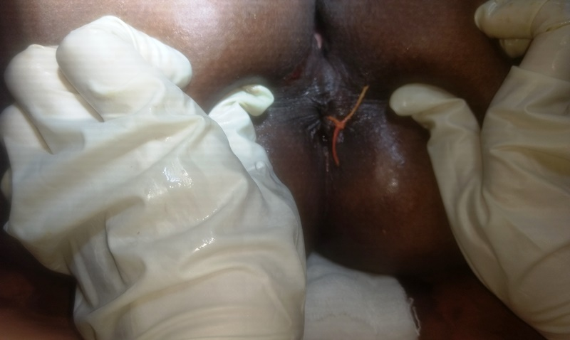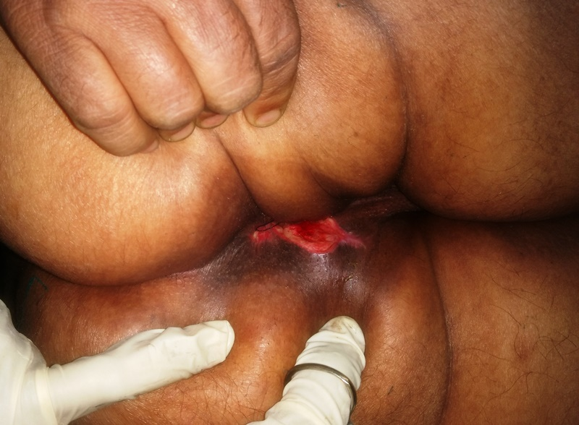

Fig 1: Ksharasutra Application in fistulous tract Fig 2: Post Ksharsutra Complete
Fistulectomy Wound

