**SCREENING OF WOUND HEALING ACTIVITY OF MADAYANTIKA**

**(*Lawsonia inermis* Linn.) IN ALBINO WISTAR RATS**

Dr.Deepthi.V 1, Dr.Renu Dixit2, Dr.K.V.Vijaya Bhaskar Reddy3

1. P.G.Scholar, Dept. of Dravyaguna, S.V.Ayurvedic College, Tirupati

2. P.G.Reader/ Professor, Dept. of Dravyaguna, S.V.Ayurvedic College, Tirupati

3. Associate Professor, Dept. of Shalyatantra, S.V.Ayurvedic College, Tirupati

E-Mail – [dr.deepthi.valigatla@gmail.com](mailto:dr.deepthi.valigatla@gmail.com) Mobile No. 8985324606

**Abstract**

*Lawsonia inermis* Linn. is a miracle medicinal plant used in the treatment of various skin diseases especially in wound healing activity in the Indian System of Medicine. **Aim and Objective**: The objective of the study presented in this article was to evaluate the wound healing potential of aqueous extract. **Screening Model:** The study was done on wistar albino rats using excision wound model. **Results:** The extract of *Lawsonia inermis* Linn., treated wounds were found to epithelize faster and rate of wound contraction was significantly (p<0.0001) increased as compared to Control Group ( p< 0.01). The extract treated animals showed 25.1 ± 0.252 reduction in wound area when compared with control groups 40.71 ± 0.166.**Conclusion:** *Lawsonia inermis* Linn. possess significant wound healing effect which may beneficial in treating wounds. This drug can be further investigated for other types of wounds and it may prove boon to many chronic wounds.

**Key Words:** Madayantikā, Lawsonia inermis Linn., Vraṇa, Chronic foot ulcers, Excision

wound model.

**Introduction:**

“Pharmacology” is one of the cornerstones of the drug discovery process. “Pharmacology” is the branch of science which deals with study of “Drug action”.

“**Experimental pharmacology**” deals with effect of various pharmacological agents studied on different animal species. Experimental pharmacology involves the study of pharmacology through bioassay to test the efficacy and potency of the drug.

In the case of majority of the drugs it is possible to determine the therapeutic ability based on basic pharmacological and therapeutic uses which were told by our Ācāryas. From Ancient period onwards only there are number of references available regarding the testing of drugs and foods on the animal for the safety of Mankind. In Caraka Saṃhitā, Siddhi sthāna (6/79-80) there are numerous references find their way to depict these procedures (1). Suśruta Saṃhitā has dealt with this by allotting a separate chapter in Sūtra sthāna i.e., Yogyavidhi (9th chapter), in which it is said that **any procedure which is expected to be performed on human being should undergo trials on animals or other things, which has same characteristics** and in Kalpasthāna there is similar discussion dealing with the observation of Animal experiments (2). Ācārya Vāgbhaṭa has also described them in more or less similar manner. These are not for the drugs and their effects on the animals, but mainly to ascertain possible adverse or poisonous effect.

The main aim of this Experimental Pharmacology as per ancient scholars and as per Modern science is same i.e.,

1. To find out the therapeutic agent suitable for human use,

2. Study the toxicity of the drugs,

3. Study the mechanism and site of action of drugs,

Commonly used animals for Experimental study are

* Mice
* Rat
* Guinea Pig
* Rabbits

Most Commonly used animals are rats because of its

* Availability
* Low cost and
* Small size

**AIM OF THE STUDY**

The present study aims to screen the *In vivo* wound healing activity of scaffolds loaded with *Lawsonia inermis* Linn.

**MATERIALS AND METHODS**

The test drug aqueous extract of *Madayantikā (Lawsonia inermis* Linn.) Patra cūrṇa is used for experimental purpose and administered to the experimental animals according to the dose required.

**Procurement of animals**

1. Healthy albino rats of Wistar strain of either sex weighing about 150-200 g were used for the study.
2. The animals were acclimatized for a period of one week prior to expose the experimental conditions. Animals were caged individually and kept in an air conditioned room at the temperature of 22 ± 24 0 C with 50% ± 10% relative humidity with 12 hours light and dark cycle.
3. Throughout the study, rats were maintained at normal laboratory conditions, fed with standard rat pellet diet and drinking water *ad libitum*.
4. The experiments were carried out after obtaining permission from “Institutional Animal Ethics Committee.”

**Apparatus:**

1. Rat feeding needles
2. Weighing Scale
3. Syringes
4. Blunted Forceps
5. Scissors
6. Cotton
7. Guaze

**Chemicals**

1. Ketamine injection
2. Xylazine injection
3. Betadine ointment (5%)
4. Normal saline
5. Surgical spirit

**Route of drug Administration**:

Route of drug administration plays a pivotal role in Āyurveda. Topical application is one of the route for administration of drug. This method produces very constant blood levels of the substance, avoiding the need for repeated animal restraint, Painful injections, Sharp hazards, lower risk of side effects.

So, topical application has given utmost importance in the present Animal Experimention.

**EXPERIMENTAL MODEL**

The model selected to evaluate in vivo wound healing activity are

* Excision wound model (3), (4)

**EXPERIMENTAL PROTOCOL**

The experimental animals were divided into 3 groups containing 6 animals in each group (n=6)

**Table No. 4.1. Showing the Experimental Protocol**

|  |  |  |  |
| --- | --- | --- | --- |
| **S.No** | **Groups** | **Treatment** | **Purpose of the study** |
| 1. | Disease control | Wound induction by Excision model | To assess the parameters in disease control |
| 2. | Standard | Wound induction by Excision wound model + Povidone Iodine (5%)ointment | To assess the parameters in betadine ointment (5%) treated group |
| 3. | Test | Wound induction by Excision model + *Lawsonia inermis* Linn.scaffolds | To assess the parameters in test treated group. |

**EXCISION WOUND MODEL**

Healthy wistar strain albino rats of either sex weighing of 150-200gm were used for the study

Animals were housed in a laboratory condition under ambient temperature of 22 ± 24 0 C with 50% ± 10% relative humidity with 12 hrs light and dark cycle. They were fed balanced diet and water ad libtium

Rats were divided into 3 groups containing 6 animals in a group (n=6)

Rats were anaesthetized with Ketamine (80mg/kg I.M) and Xylazine (10mg/kg I.M) prior to experimentation

Dorsal surface of the rats were shaved to avoid interruption of hairs during experimental period

An area of about approximately 500mm2 was marked on the dorsal surface of the rat and then the marked skin was cut carefully with help of sterilized forceps

Wounds were left undressed to open environment

Then the animals were closely observed for any infection and those which showed signs of infection were separated and excluded from the study and replaced with other animals

The extracts of test drugs, scaffolds containing aqueous extract of *Lawsonia inermis* Linn. , the standard drug betadine (5%) ointment were applied on the wound area immediately

Wound dressing was done once a day after washing the wound carefully with 0.9% saline water and mopping with the sterile non-absorbable cotton till the wound was completely healed

The scaffolds containing *Lawsonia inermis* Linn., betadine ointment (5%) were applied on the wound area and the animals were observed for wound closure at 0day, 7thdayand 15thday and for period of epithelialization

The progressive changes in wound area were monitored by a camera for every 5 days

**STATISTICAL ANALYSIS**

All the data was expressed as mean ± SEM. Statistical significance between more than 2 groups was tested using one way ANOVA followed by the Dennett’s test. Statistical significance was determined at p ˂0.05.

**RESULTS:**

**Table. No. 4.2. Effect of *Lawsonia inermis* Linn. Scaffolds on excision Wound of all Groups**

|  |  |  |  |  |
| --- | --- | --- | --- | --- |
| **S.No.** | **Groups** | **Wound area in mm2** | | |
|  |  | **0 day** | **7 th day** | **15 th day** |
| 1. | **Control** | 502 ± 0.538 | 317 ±1.72 | 40.71 ± 0.166 |
| 2. | **Standard** | 502 ± 0.367 ns | 233 ± 0.728*** | 15.3 ± 0.098*** |
| 3. | ***Lawsonia inermis* Linn.** | 502 ± 0.364 ns | 261 ± 0.372** | 25.1 ± 0.252*** |

***p<0.0001, **p<0.001, ns when compared with control group

**Graph.No.1.Effect of *Lawsonia inermis* Linn. Scaffolds on excision Wound of all Groups on Zero day**

**Graph. No. 2. Effect of *Lawsonia inermis* Linn. Scaffolds on excision Wound of all groups on 7th day**

**Graph No. 3. Effect of *Lawsonia inermis* Linn. Scaffolds on excision Wound of all groups on 15th day**

**Excision wound Model Images**

Zero day

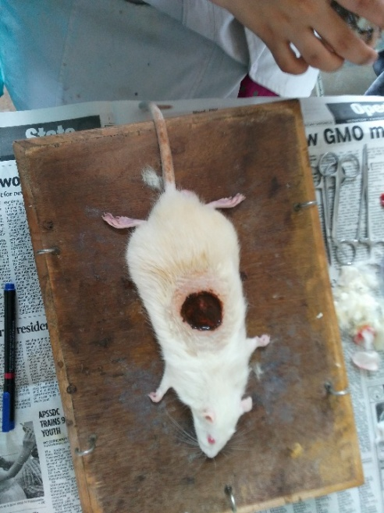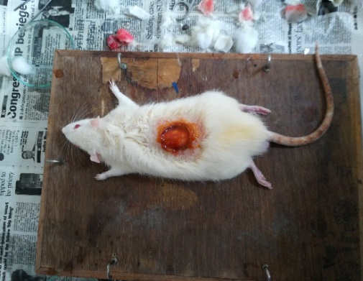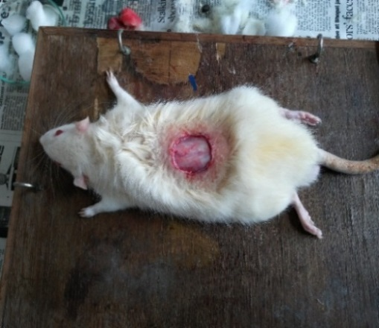

Fig 35: Disease control Fig 36: Betadine (5%) Fig 37:*Lawsonia inermis* Linn. treated

7th day

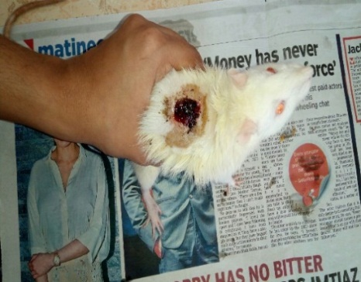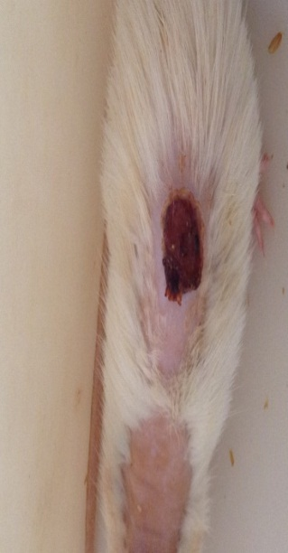 

Fig 38: Disease control Fig 39: Betadine ointment (5%) Fig 40: *Lawsonia inermis* Linn. Treated

15thday

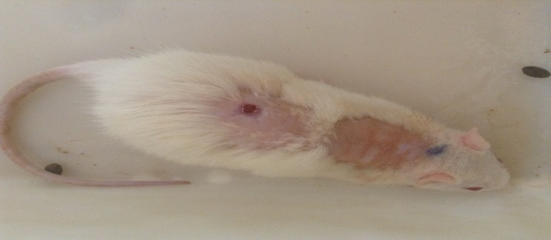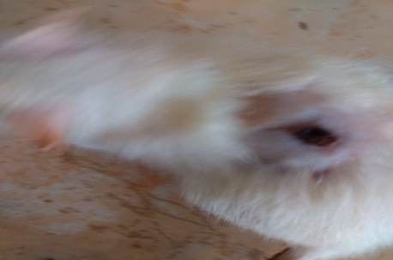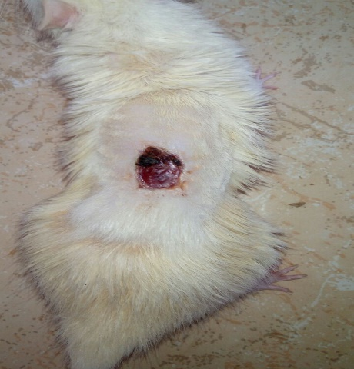

Fig 41: Disease control Fig42: Betadine ointment (5%) Fig 43: *Lawsonia inermis* Linn. treated

**DISCUSSION**

Wounds are physical injuries that result in an opening or breaching of the skin leads to disruption of normal physiological state of skin. In order to maintain normal homeostasis proper healing of wound is essential for the restoration of disrupted anatomical stability and functional status of the skin. Wound healing is an intricate process in which the skin itself repairs the injury in sequential events which involves inflammation, proliferation and remodeling.

Whenever there is a breach to the skin integrity occurs, platelets are the first cells responds to the injury and initiate wound healing through fibrin clot formation. In mean while inflammatory process begins with recruitment of inflammatory mediators such as neutrophils, macrophages etc., to the injured site. Neutrophils acts as chemo attractants for other cells involved in inflammation and it also releases mediators such as TNF-α and interleukins (5). Macrophages play a multiple roles by releasing cytokines which promotes inflammatory response by recruiting other additional leucocytes (6).

In proliferative phase, the main wound healing process lies in cells like fibroblasts and endothelial cells play an important role in collagen synthesis, formation of blood vessels and formation of granulation tissue at the injury site. Tissue repair process is mediated by the release of growth factors (EGF, PDGF, VEGF). The released growth factors promote cell proliferation angiogenesis and synthesis ECM molecules by resident skin cells (7).

Remodeling phase is the last phase of wound healing process occurs from 21stday to upto 1 year after injury. The formation of granulation tissue stops and leads to wound contraction by them fibroblasts by attaching to collagen.

Present study is mainly focused to screen *in vivo* wound healing activity of scaffold loaded with *Lawsonia inermis* Linn., It was observed that scaffold loaded with *Lawsonia inermis* Linn. treated groups showed significant increase in wound closure time by enhancing epithelization when compared with that of Control group and wound repair in *Lawsonia inermis* Linn. treated group started from the 5th day onwards. This prominent increase in epithelisation may be due to the mitogenic property of the *Lawsonia inermis* Linn. treated groups and also the presence of various phytochemical constituents like Tannins, Flavanoids, Terpenoids and Saponins, Which have anti-bactrerial, anti-inflammatory, anti-fungal activity. Metal analysis showed the presence of Sodium, Potassium, Iron, Manganese, chromium in leaf powder of Madayantikā. Sodium helps in electrolyte balance in the body where as potassium is helpful in muscle contraction such that it drains out the fluid and helps in muscle contraction such that it drains out the fluid and helps in formation of healthy granulation tissue. Copper enable the body to form RBC and blood vessels and also plays key role in angiogenesis. Iron is having potent anti-oxidant wound healing. Chromium plays key role in angiogenesis. Manganese activates a enzyme prolidase which has the collagen formation effect so it helps in wound healing. In this way Sodium, potassium, Iron, Copper, Chromium and Manganese in *Lawsonia inermis* Linn. plays significant role in wound healing. Since, these ion’s are important for wound healing.

**CONCLUSION:**

The wound healing property of leaf extract of *Lawsonia inermis* Linn. appears to be due to the presence of its active principles which accelerates the healing process. The present study has demonstrated that an aqueous extract of *Lawsonia inermis* Linn., leaves has properties that render it capable of promoting wound healing. Finally, it may concluded that *Lawsonia inermis* Linn. possess significant wound healing effect which may beneficial in treating wounds. This drug can be further investigated for other types of wounds and it may prove boon to many chronic wounds.

**REFERENCES:**

1. Śarma R.K, Bhagawan Das, Caraka Saṃhitā of Agniveśa, revised by Caraka and Dṛḍabala, Chowkhamba Krishna Das Academy, Vāranāsi 2010. Siddhi sthāna (6/79-80)
2. Ācārya Suśruta, Suśruta Saṃhitā, Vol.I-III, Edited and Published by Prof. G. D. Singhal, Chowkhambha Sanskrit Pratisthan, Delhi, Reprint 2007. Sūtra sthāna i.e., Yogyavidhi (9th chapter).
3. Pulok K. Mukherjee, Rob Verpoorte , B. Suresh., Evaluation of in-vivo wound healing activity of *Hypericum patulum* (Family: Hypericaceae) leaf extract on different wound model in rats.,Journal of Ethnopharmacology 70 ( 2000 ) 315 – 321.
4. Nalesh Malviya& Sanjay Jain., Wound healing activity of aqueous extract of *Radix paeoniae* root, Acta Poloniae Pharmaceutica; Drug Research, vol 66 No 5pp-543-547.
5. A.Nauta, G.C.Gutner, MT Longaker., Wound healing and Regenerative Strategies, www.wiley.com; oral diseases, 2011 17,541-549.
6. S. Guo and L.A. DiPietro.,Factors Affecting Wound Healing., J Dent Res 89(3) 2010.
7. J.M. Reinke, H. Sorg., Wound Repair and Regeneration, Eur Surg Res 2012; 49:35-43